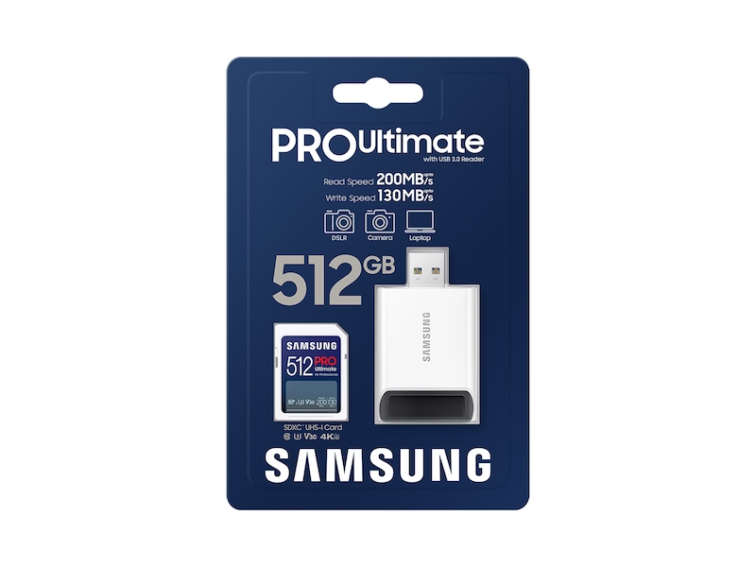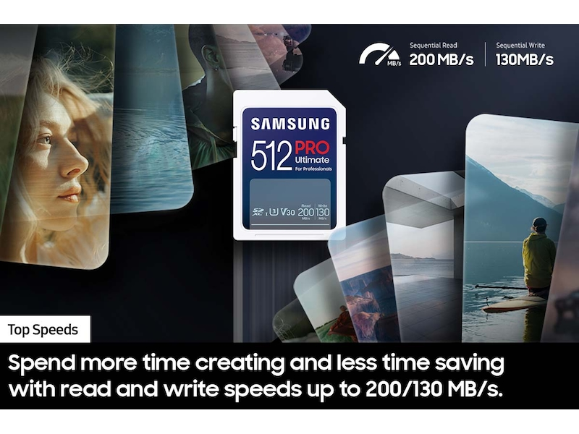

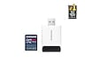

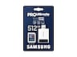









**Samsung.com Advantage**



**Pay in 4 installments**

BOPIS

**In-Store Pickup available**

**Free, No Contact Delivery**

**Key Features**

PRO Ultimate

Series

512GB

Capacity

200MB/s Read Speed

130MB/s Write Speed

• Spend more time creating and less time saving with read and write speeds up to 200/130 MB/s¹ when using Samsung USB readers.  
  
• Whether you’re using a DSLR camera or a PC, count on the PRO Ultimate for compatibility.⁴  
  
• Designed to survive the rough and tumble of field work, the PRO Ultimate has built-in protection from elements like water and heat.⁵-¹²  
  
• Save every second in mere minutes with storage capacities ranging from 64GB to 512GB.

Storage

**64GB**

$15.99$19.99

**Save $4.00**

**128GB**

$14.99$25.99

**Save $11.00**

**256GB**

$24.99$52.99

**Save $28.00**

**512GB**

$73.99$97.99

**Save $24.00**

**VIP Advantage**

**VIP Advantage membershipLearn more**

* 2 Year Samsung Care+ (without Theft and Loss)
* Exclusive Discounts & Early Access

To select this option, please sign in or create a Samsung account

**Premium Benefits**

**$149.99/yr**

**Delivery & professional services**

Availability for:

96928

Delivery

**Delivery**

Not available



**In-Store Pickup**

Not available

This product is currently not available in your area.

**Choose your purchase option**

iconQuestions? Ask a Financing Expert

**One-time Payment**

**$73.99**

**Pay in 4 Installments**

**$18.50**

**every two weeks σπ**

**One-time payment**

Pay with your credit card, debit card or a pay app. Excludes taxes and shipping.

**PRO Ultimate + Reader Full Size SDXC Card 512GB$73.99**

**Total**

**$73.99 $97.99**

**You Saved Today$24.00**



**Log in now to earn up to 1.5% back in Samsung Rewards Points**

**Add to cart**

[**Where to buy**](https://www.samsung.com/us/computing/memory-storage/memory-cards/pro-ultimate-reader-full-size-sdxc-card-512gb-mb-sy512sb-am-buy)

Supported payment types:

adyen_cardsPayPal Venmo Checkoutamazonpaygooglepay

**Made for expert-level endeavors**

Meet the best of our best. The PRO Ultimate SD card offers our fastest speeds and high storage capacity to keep up with any endeavor. Extremely fast read and write speeds with multi-device compatibility help you power through your creative pursuits.

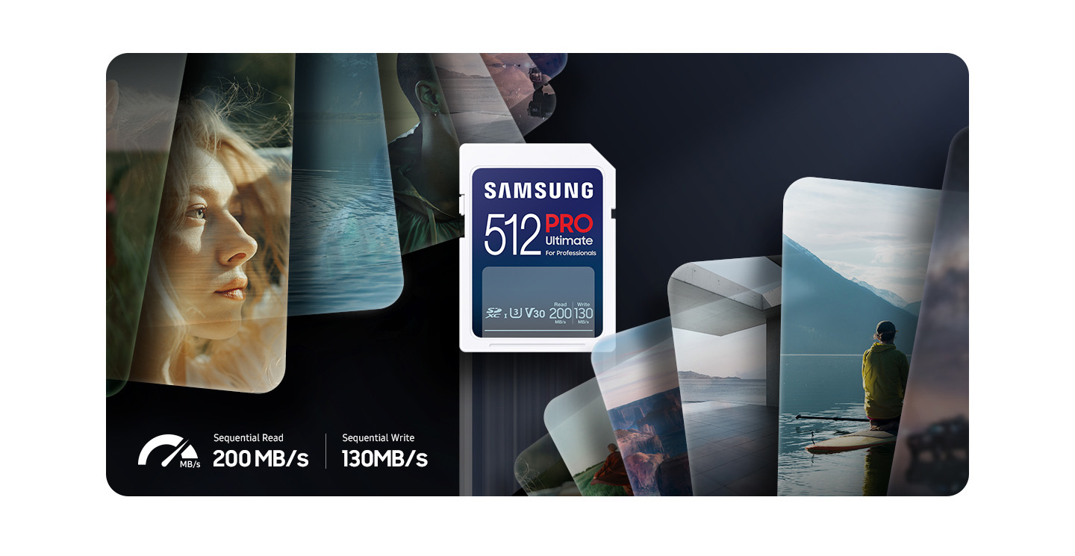

**Fast just got faster**

Read/Write Speeds up to 200/130 MB/s

The PRO Ultimate makes it easy to complete each task. Spendmore time creating and less time saving with read and write speeds up to 200/130 MB/s¹ when using Samsung USB readers. It also features state of the art U3 and V30 ratings² with A2  
performance³ that helps with fast loading and 4K UHD video capture.